Upon Running:



Which contains:

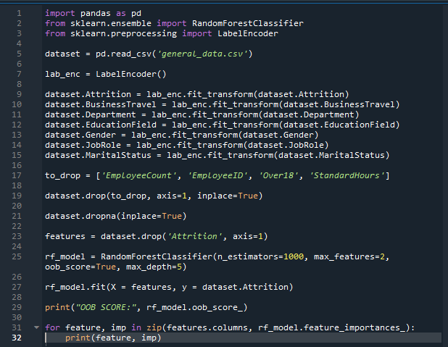

We get output:

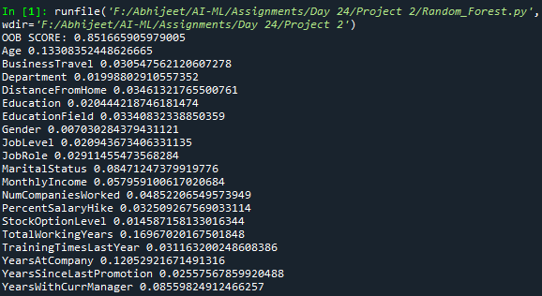

From which we conclude:

Only Age, TotalWorkingYears, YearsAtCompany and YearsWithCurrManager have a decent importance

So we use these to build Decision Tree:

We run:

Which contains:

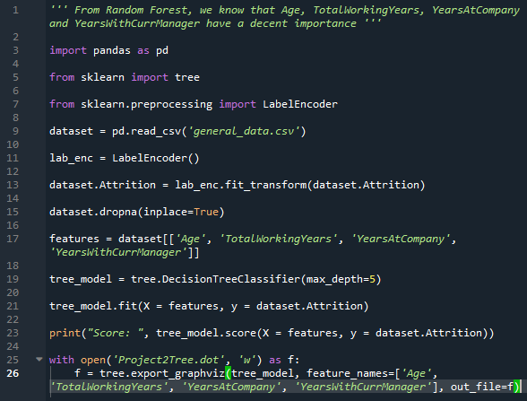

We get output:



And



Upon running this file on webgraphviz.com we get a tree that looks like:

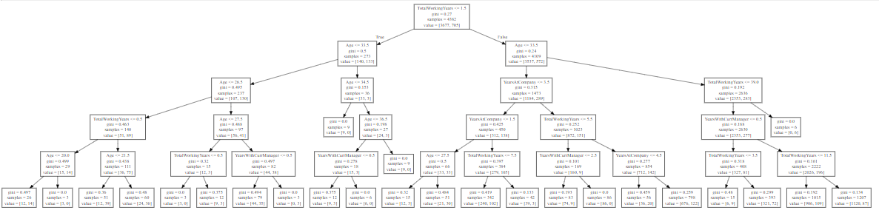

The Rule-Set is:

1. If Employee’s **Age <=26.5** and **> 20** , **TotalWorkingYears <= 0.5** , He/She **Didn’t Leave**
2. If Employee’s **Age <= 27.5** and **> 26.5** , **TotalWorkingYears <= 0.5** , He/She **Didn’t Leave**
3. If Employee’s **Age <= 33.5** and **> 27.5** , **YearsWithCurrManager > 0.5** , **TotalWorkingYears <=1.5** , He/She **Left**
4. If Employee’s **Age <= 34.5** and **> 33.5** , **TotalWorkingYears <= 1.5** , He/She **Didn’t Leave**
5. If Employee’s **Age > 36.5** , **TotalWorkingYears <= 1.5** , He/She **Didn’t Leave**
6. If Employee’s **Age <= 36.5** and **> 34.5** , **YearsWithCurrManager > 0.5** , **TotalWorkingYears <= 1.5** , He/She **Didn’t Leave**
7. If Employee’s **Age <= 27.5** and **> 33.5** , **TotalWorkingYears > 39** , He/She **Left**